✅ Exploring
This lesson introduces the Exploration phase of the A.W.E.S.O.M.E framework. After scrubbing (cleaning) data using pandas, the next step is to explore it to understand patterns, structure, and context. Exploration helps you discover what the data is telling you before modeling or making decisions.
Exploration includes:
- Looking at numerical summaries (statistics, subsets, filters)
- Creating visualizations (charts and graphs)
- Using pandas plus visualization tools to find patterns, anomalies, trends, or outliers
- Iterating: explore → discover something new → explore more
Exploration bridges cleaning and modeling, giving you intuition and deeper insight into the data.
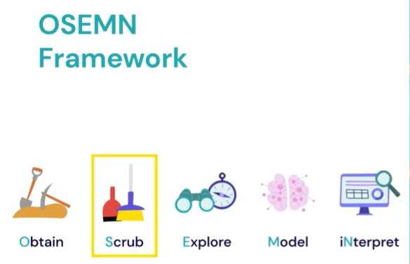

🧠 Data Exploration Cheat Sheet (Short Table)
Goal / Task | Code Snippet
Preview & inspect structure | df.head() / df.info()
Summary statistics (numeric) | df.describe()
Filter rows (focus on subsets) | df[df['Age'] > 30]
Group and analyze (patterns) | df.groupby('Gender')['Spend'].mean()
Sort data (find extremes) | df.sort_values(by='Spend', ascending=False)
Check distributions (histogram) | df['Age'].hist()
Scatter plot (relationships) | df.plot.scatter(x='Age', y='Spend')
Bar chart (categories) | df['Category'].value_counts().plot.bar()

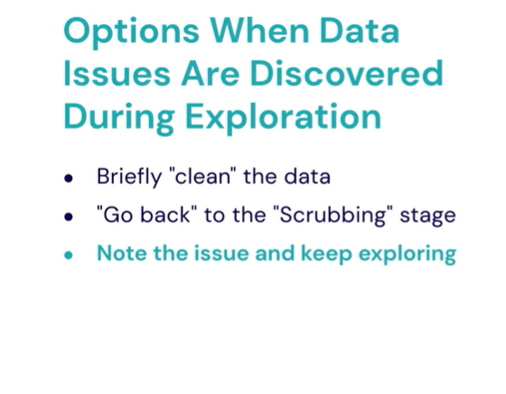
Key exploration functions covered:
Purpose | Method | Output
Basic info (rows, columns, datatypes, missing values) | df.info() | Quick overview of dataset cleanliness & structure
Preview first rows | df.head() | Shows first few rows
Preview last rows | df.tail() | Shows last few rows
Random sample of rows | df.sample() or df.sample(n) | Good for spotting anomalies in the middle of dataset
Statistical overview of numeric columns | df.describe() | Shows count, mean, std, min, quartiles, max
You also used individual statistical methods:
- df.column.mean()
- df.column.std()
- df.column.min()
- df.column.max()
- df.column.median()
- df.column.quantile() → ex: df.column.quantile(0.25)
Important Concepts:
- Mean → average value
- Standard deviation (std) → shows how spread out the data is
Smaller std = values close to mean
Larger std = data more spread out
- Percentiles / Quantiles → 25%, 50% (median), 75%
- IQR (Interquartile Range) = 75% – 25% percentile → used to detect outliers

📚 Cheat Sheet (Exam-Ready Table)
Task / Concept | Code Example | Description
Import pandas | import pandas as pd | Enables data handling in Python
Load CSV from URL | df = pd.read_csv("url_to_csv") | Reads CSV into a DataFrame
View basic dataset info | df.info() | Shows types, non-null counts, column names
Show first rows | df.head() | Peek at beginning of dataset
Show last rows | df.tail() | Peek at end of dataset
Random row sample | df.sample() / df.sample(10) | Shows random row(s) from dataset
Summary statistics | df.describe() | Shows mean, std, Min, Max, Percentiles
Mean | df["col"].mean() | Average value of a column
Standard deviation | df["col"].std() | Spread/variance of column values
Minimum value | df["col"].min() | Smallest value
Maximum value | df["col"].max() | Largest value
Median (50% percentile) | df["col"].median() | Middle value
Percentile / Quantile | df["col"].quantile(0.25) | Returns 25th percentile
Remove column(s) | df.drop(columns="col") | Removes unwanted columns (returns new df)

✅ Exploration: Filtering Data
In this lesson, you explored how to drill down into specific subsets of data using Pandas. Instead of only viewing overall dataset statistics (mean, median, etc.), you learned how to filter and analyze groups — for example, comparing kids, teenagers, young adults, and adults to study their spending habits.
Key learnings:
- Use boolean filtering to create subsets (e.g., kids < 13, teenagers 13–17, adults >=18).
- Apply column statistics to subsets: .mean(), .median(), .sum()
- Use .agg() to compute multiple statistics at once for a DataFrame/Series.
- Automate repeated analysis using loops and dictionaries.
- Use functions to make analysis flexible (e.g., compute % of group spending at least a certain amount).
- Exploration is iterative — ask questions, explore, refine.

📋 Cheat Sheet: Subset Filtering & Exploration with Pandas
Goal / Concept | Code Example | Result / Description
Import and load data | import pandas as pd, df = pd.read_csv("customers.csv") | Load dataset into DataFrame
Quick dataset overview | df.info() | Columns, data types, missing data
Summary statistics | df.describe() | Count, mean, std, percentiles
Create filtered subsets | kids = df[df["age"] < 13], teens = df[(df["age"] >= 13) & (df["age"] < 18)], adults = df[df["age"] >= 18] | Create groups using boolean masks
Statistics on filtered subset | kids["total_charges"].mean() | Average spending for kids
Multiple stats at once | kids["total_charges"].agg(["mean", "median"]) | Returns both mean & median
Loop through groups | age_groups = {"kids": kids, "teens": teens, "adults": adults}  for name, group in age_groups.items(): print(name, group["total_charges"].agg(["mean","median"])) | Automatically prints stats for each group
Define function for repeated analysis | def percent_purchase_at_least(group, amt): count = (group["total_charges"] >= amt).sum() total = group["total_charges"].count() return count / total | Calculate % of group spending ≥ given amount
Use function in loop | for name, group in age_groups.items(): print(name, percent_purchase_at_least(group, 100)) | Shows % of each group spending ≥ $100

🔑 Key Pandas Concepts
- Boolean filtering creates subsets:
df[df["column"] > value]
- .agg() applies multiple functions to a column.
- .sum() on boolean values counts True entries.
- Organize code using lists/dicts + loops to avoid repetition.
- Data exploration = ask → analyze → refine.

🟩 Flashcards (Q ➝ A)
Flashcard 1
Q: What is the goal of the exploration phase?
A: To understand the data — find patterns, trends, anomalies, insights — before modeling.

Flashcard 2
Q: What Pandas function shows summary statistics (mean, std, percentiles)?
A: df.describe()

Flashcard 3
Q: How do you filter rows in Pandas using a condition?
A: df[df["column"] > value]

Flashcard 4
Q: How do you select subsets based on age ranges?
A:
kids = df[df["age"] < 13]
teens = df[(df["age"] >= 13) & (df["age"] < 18)]
adults = df[df["age"] >= 18]

Flashcard 5
Q: What does .agg() do in Pandas?
A: Applies multiple statistical functions at once.
Example: df["sales"].agg(["mean", "median"])

Flashcard 6
Q: How can you count how many values meet a condition using boolean logic?
A: (df["column"] > value).sum()

Flashcard 7
Q: Why loop over a dictionary of subsets?
A: To avoid repeating code when analyzing multiple filtered groups.

Flashcard 8
Q: What is a benefit of defining functions during exploration?
A: Makes repeated analysis easier and more flexible (e.g., testing different thresholds).

📝 Practice Quiz
1. Multiple choice
You want to see the highest and lowest values in a column age. What code do you use?
a) df.age.info()
b) df["age"].min(), df["age"].max()
c) df.age.count()
d) df.head()
✏️ Write your answer: ___

2. Short-answer
Write a filter that selects only customers with charges ≥ 200.
✏️ Code: _________________________________________

3. True/False
Filtering with df[df["age"] > 30] returns a new DataFrame.
✏️ Answer: ___

4. Fill in the blank
To compute both mean and median of the column total_charges:
df["total_charges"].____(["____", "____"])

5. Code writing task
Given a subset named kids, print the average of the column total_charges.
✏️ Code:
_________________________________________

Answer key (hidden — expand only when done):
Answer Key
1: b
2: df[df["total_charges"] >= 200]
3: True
4: .agg(["mean", "median"])
5: kids["total_charges"].mean()

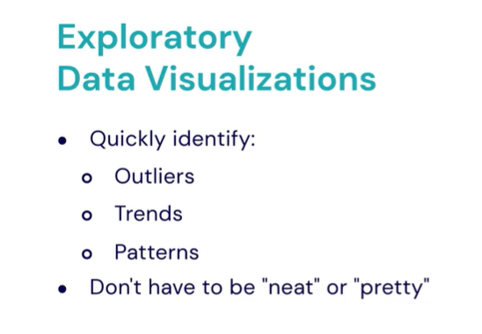
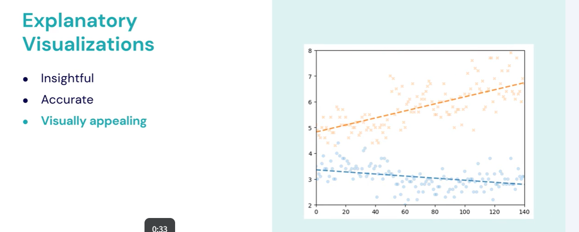

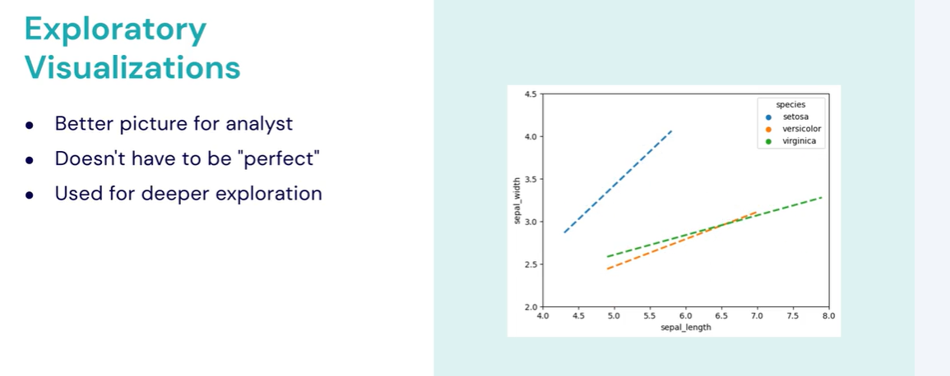
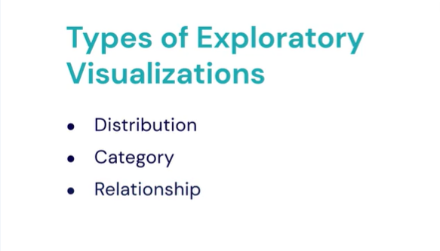

🧠 Summary: Exploratory Data Visualizations — Distributions
Exploratory visualizations help analysts understand the shape and spread of data. One major type focuses on distributions, which show how values are spread or clustered across a range.
There are three main visualization types for analyzing distributions:

1. Box Plot
- Represents data through quartiles (Q1–Q3) and highlights outliers.
- The box covers the interquartile range (IQR) — middle 50% of the data (25th–75th percentile).
- The line inside the box shows the median.
- Outliers are displayed as dots beyond whiskers.
- Can be shown vertically or horizontally.
- Provides a quick statistical summary — similar to what .describe() gives in Pandas.

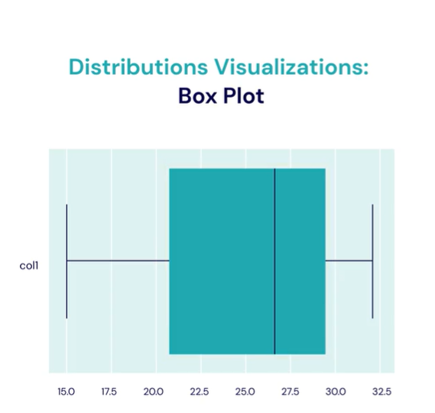

2. Violin Plot
- Extends the box plot by showing the density (shape) of the distribution.
- The width of the violin shows where data points are more concentrated.
- Includes an internal box plot to indicate quartiles and median.
- Helps visualize multiple peaks (bimodal distributions) that box plots may hide.
- Can also be horizontal or vertical.

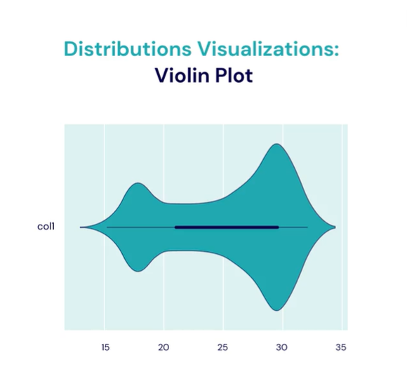

3. Histogram
- Displays the frequency of data values in bins along the x-axis.
- The height of each bar represents how often data fall into that range.
- Great for visualizing peaks, gaps, and spread in continuous data.
- Easier to interpret than summary statistics for understanding data distribution.
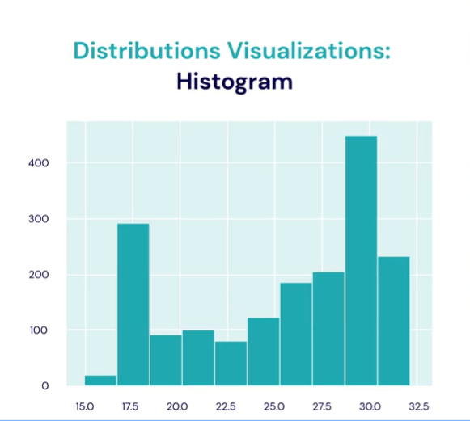
Each of these visuals provides different insights into the same dataset.
👉 It’s best to use multiple visualizations to understand a dataset’s distribution fully.

📊 Cheat Sheet: Distribution Visualizations
Visualization | Key Feature | Shows | When to Use
Box Plot | Quartiles (IQR), Median, Outliers | Summary of data spread | Quick statistical overview
Violin Plot | Density + Quartiles | Shape + concentration of data | Detect multimodal distributions
Histogram | Frequency bars | Distribution shape + spread | See how often values occur

🧩 Bonus: Pandas/Seaborn Quick Commands
import pandas as pd
import seaborn as sns
import matplotlib.pyplot as plt

# Box plot
sns.boxplot(x='column_name', data=df)

# Violin plot
sns.violinplot(x='column_name', data=df)

# Histogram
sns.histplot(df['column_name'], bins=20, kde=True)
plt.show()

🧠Category-Type Exploratory Visualizations

🔹 Purpose:
Category visualizations are used to compare numerical values across categorical groups.
They help reveal differences, trends, and patterns between categories (e.g., species, gender, region).
You can think of them as showing how one categorical variable affects a numerical variable.

🔹 Example:
Comparing average penguin weights across species.
Species | Average Weight (kg)
Adeli | 3.75
Chinstrap | 3.85
Gentoo | 5.00
This can be visualized using a bar chart, where:
- X-axis → Categories (e.g., penguin species)
- Y-axis → Numeric values (e.g., average weight)
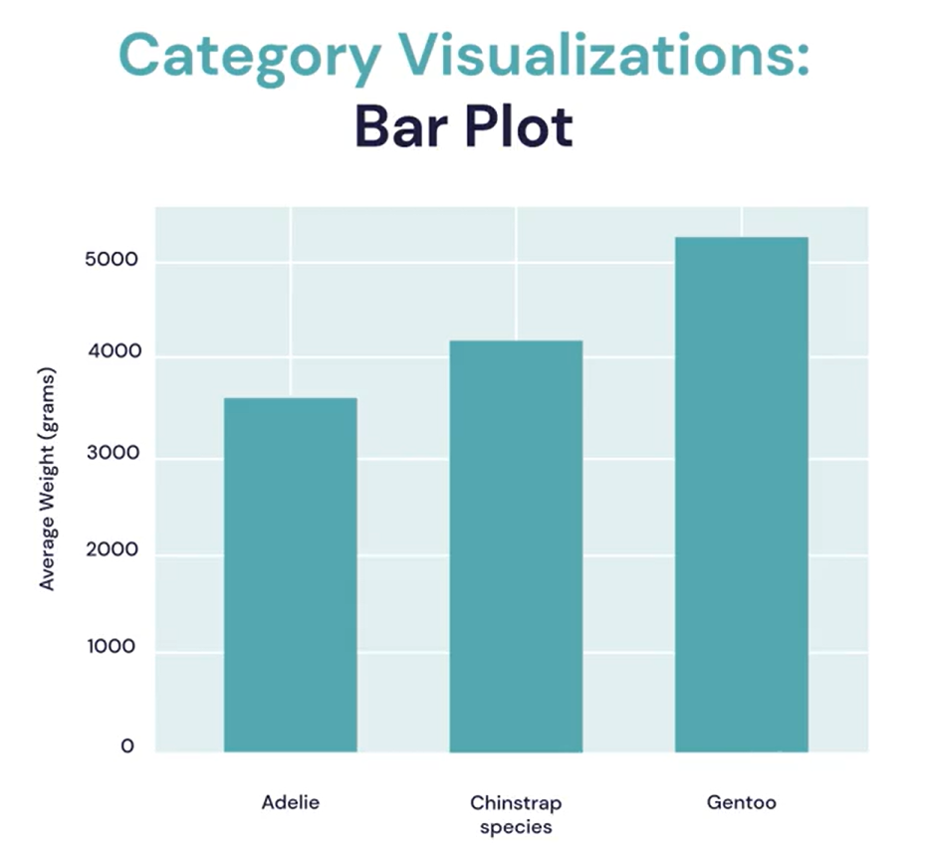

🔹 Common Variations of Category Visualizations:
Visualization | Description | Use Case
Bar Plot / Bar Chart | Displays categories as bars, height = metric (e.g., mean, sum, count). | Compare means or counts across groups.
Grouped Bar Chart | Adds subcategories (e.g., male vs. female per species) side-by-side. | Compare subgroups within each category.
Stacked Bar Chart | Stacks subcategory values within one bar. | Show composition or contribution to the total.
Count Plot | Bar chart of category frequencies (no numeric y-variable). | Show how often each category appears.

🔹 Example Insights:
- Average weight differs by species.
- Adding gender reveals deeper patterns (e.g., female Chinstrap penguins are heavier than males).
- Grouped bar charts help identify such relationships that single-category charts can miss.

🔹 Example Python Code (using Seaborn & Matplotlib)
import seaborn as sns
import matplotlib.pyplot as plt

# Basic bar chart — average body mass per species
sns.barplot(x="species", y="body_mass_g", data=penguins)
plt.title("Average Penguin Weight by Species")
plt.show()

# Grouped bar chart — species by gender
sns.barplot(x="species", y="body_mass_g", hue="sex", data=penguins)
plt.title("Average Weight by Species and Gender")
plt.show()

# Stacked bar (using Pandas)
df_grouped = penguins.groupby(["species", "sex"]).size().unstack()
df_grouped.plot(kind="bar", stacked=True)
plt.title("Stacked Bar: Count by Species and Sex")
plt.show()

🧾 Cheat Sheet: Key Concepts
Concept | Definition | Example
Categorical Variable | Non-numeric labels or groups. | Species, Gender, City
Numerical Variable | Quantitative measurement. | Weight, Income, Age
Goal | Compare numeric values between categories. | Average income by country
Best Plots | Bar chart, Grouped bar, Stacked bar, Count plot | sns.barplot(), sns.countplot()
Insight Example | "Female Chinstrap penguins weigh more than male Chinstrap penguins."

🎯 Quick Exam-Style Questions
- What is the primary purpose of category visualizations?
→ To compare numerical values across categorical groups.
- Which plot is best for showing proportions within each category?
→ Stacked bar chart.
- What does the “hue” argument in Seaborn’s barplot() do?
→ It adds a subcategory (e.g., gender) to group data within each category.
- What happens if your data has no numerical variable?
→ Use a count plot to visualize frequency per category.
- True or False:
A bar chart is ideal for showing the correlation between two numeric variables.
→ ❌ False — that’s a relationship visualization (e.g., scatter plot).

🧠 Summary: Visualizing Data with Pandas
This lecture introduces how to create basic visualizations directly in Pandas to quickly understand data distributions and relationships. Using the Tips dataset, it demonstrates exploratory data analysis (EDA) through df.describe(), box plots, histograms, and scatter plots.

🧾 1. Dataset Overview
- Dataset: tips — restaurant tips collected by a waiter.
- Columns:
  - total_bill → Amount before tip
  - tip → Tip amount
  - sex → Gender of customer
  - smoker → Smoker or not
  - day, time → When the meal occurred
  - size → Party size

📊 2. Exploratory Data Summary
Function | Purpose
df.head() | View first few rows
df.info() | Data types & missing values
df.describe() | Summary statistics (mean, median, IQR)

📦 3. Box Plots
Used to visualize median, spread, and outliers.
Command | Description
df.plot.box() | Boxplots for numeric columns
df.plot(kind='box', vert=False) | Horizontal boxplots
df[['tip', 'total_bill']].plot.box() | Select specific columns
df.plot.box(column=['tip', 'total_bill']) | Alternative syntax
Interpretation Tips:
- Green line = median
- Box = Interquartile Range (IQR = middle 50%)
- Dots = outliers

📈 4. Histograms
Used to visualize data distribution and frequency.
Command | Description
df.plot.hist() | Combined histogram for numeric columns
df.plot.hist(alpha=0.5) | Add transparency
df['tip'].plot.hist(bins=20) | Individual column histogram
Findings:
- Most party sizes = 2
- Tip & total_bill distributions look similar (tips ≈ % of bill)

⚫ 5. Scatter Plots
Used to show relationships between two numeric variables.
Command | Description
df.plot.scatter(x='total_bill', y='tip') | Tip vs Bill relationship
df.plot.scatter(x='size', y='tip') | Tip vs Party size
df.plot.scatter(x='size', y='total_bill') | Bill vs Party size
df.plot.scatter(x='total_bill', y='tip', alpha=0.25) | Add transparency to reveal clusters
Insights:
- Positive correlation between total_bill and tip.
- Tips rise as total bills increase.
- Density clusters visible with alpha.

🧩 6. Combining Plots (Preview)
Multiple scatter plots can share one axis:
ax = df.plot.scatter(x='size', y='tip', color='blue', label='Tip')
df.plot.scatter(x='size', y='total_bill', color='red', label='Total Bill', ax=ax)
→ Produces overlapping plots with shared axes.

🧮 Cheat Sheet: Key Commands
Task | Pandas Command
Load dataset | df = sns.load_dataset('tips')
Quick stats | df.describe()
Boxplot | df.plot.box(vert=False)
Histogram | df['tip'].plot.hist(alpha=0.5)
Scatter plot | df.plot.scatter(x='total_bill', y='tip', alpha=0.3)
Multiple plots | df.plot(kind='box', column=['tip','total_bill'])
Adjust transparency | alpha=0.5
Combine plots | Use ax=ax parameter

🧠 Exam Tips
- Box Plot → Median & spread (IQR).
- Histogram → Frequency distribution.
- Scatter Plot → Correlation between two variables.
- Alpha (0–1) → Controls transparency.
- .plot(kind='…') → Universal Pandas plotting pattern.
- Visuals are for exploration, not precise measurement — use .describe() for exact values.

🎨 Matplotlib & Pandas Visualization — Exam Cheat Sheet

🧠 Concept Overview
Matplotlib → Core Python library for data visualization.
Pandas plots → Built on top of Matplotlib.
Matplotlib creates Figures (canvas) containing one or more Axes (charts).
→ Think of Figure = paper, Axes = chart drawn on it.
Two styles:
- Implicit (plt.plot()) – Quick & simple
- Explicit / Object-Oriented (OO) (ax.plot()) – Flexible & preferred

⚙️ Setup & Basics
import pandas as pd
import matplotlib.pyplot as plt
import seaborn as sns

df = sns.load_dataset('tips')
Check data
df.info()
df.head()
df.describe()
Key columns:
total_bill, tip, sex, smoker, day, time, size

📈 Scatter Plots

✅ Basic:
df.plot.scatter(x='total_bill', y='tip', alpha=0.5)

✅ Combine multiple plots:
ax = df.plot.scatter(x='size', y='tip', color='blue', label='Tip')
df.plot.scatter(x='size', y='total_bill', color='red', label='Bill', ax=ax)

✅ Add titles & labels:
ax.set_title("Party Size vs Tip and Bill")
ax.set_ylabel("Dollars")
ax.set_xlabel("Party Size")
💡 Tip: alpha makes points transparent for dense plots.

🧩 Matplotlib Structure
Component | Description | Example
Figure | Canvas for plots | fig, ax = plt.subplots()
Axes | Actual plotting area | ax.plot(x, y)
Object-Oriented | Preferred method | ax.set_title('Title')

🪄 Feature Engineering
Create new derived column:
df['tip_percent'] = df['tip'] / df['total_bill']
Interpretation:
- Avg ≈ 16%
- Median ≈ 15%
- Range ≈ 3–71%

📦 Box Plot
Visualize spread and outliers:
df['tip_percent'].plot.box()
Interpretation:
- Median line → ~15–16%
- IQR → middle 50% (≈13%–20%)
- Dots → outliers
Alternate:
df.plot(kind='box', vert=False)

📊 Histogram
Show distribution (frequency):
df['tip_percent'].plot.hist(range=(0,1), bins=20)
Tuning options:
- range=(0,1) → fix limits
- bins=20 → controls bar width
- alpha=0.5 → transparency
Insight:
Most tips fall between 10–20%.

⚡ Combining Pandas & Matplotlib
All Pandas .plot() methods return a Matplotlib Axes object.
Use ax= to layer or customize:
ax = df.plot.scatter(x='total_bill', y='tip')
df.plot.scatter(x='total_bill', y='tip_percent', color='red', ax=ax)
ax.set_title("Total Bill vs Tip & Tip %")

🧮 Common Commands Quick Table
Purpose | Command | Notes
Create fig/axes | fig, ax = plt.subplots() | OO structure
Scatter | df.plot.scatter(x, y) | Numeric cols only
Box plot | df.plot.box() | Summary view
Histogram | df.plot.hist() | Continuous data
Add label/title | ax.set_xlabel('X'); ax.set_title('Title') | OO style
Combine plots | ax=ax | Reuse same axes
Transparency | alpha=0.3 | For overlap
Adjust range | range=(min, max) | Histograms
New feature | df['new'] = ... | Feature engineering

🧩 Key Insights for Exams
✅ Pandas plots = Matplotlib in disguise
✅ Figure → Whole canvas; Axes → Actual plot
✅ Use explicit interface (ax.) for multiple or custom plots
✅ ax=ax → stack multiple visuals on same plot
✅ Box plot = IQR summary
✅ Histogram = data distribution
✅ Scatter = variable relationships
✅ Feature engineering (e.g., tip_percent) adds analytical depth
✅ Use alpha, range, bins to refine visuals

🎯 Fast Recap
- Import: import matplotlib.pyplot as plt
- Create: fig, ax = plt.subplots()
- Plot: df.plot.scatter(x, y, ax=ax)
- Customize: ax.set_title('Title'); ax.set_ylabel('Y')
- Analyze: describe(), box(), hist(), scatter()

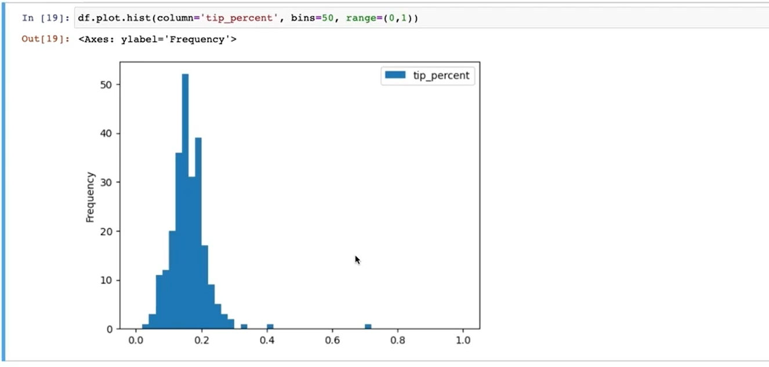

the command examples from the lecture on Pandas Aggregations & GroupBy 👇

🧮 Basic Aggregation Commands
df['column'].min()
df['column'].max()
df['column'].mean()
df['column'].median()
df['column'].sum()

🔍 Apply Aggregation to Multiple Columns
df[['col1', 'col2']].mean()
df[['col1', 'col2']].sum()

👥 GroupBy Basics
df.groupby('group_column')
View groups:
df.groupby('group_column').groups

📊 GroupBy + Aggregation
df.groupby('group_column')['value_column'].sum()
df.groupby('group_column')['value_column'].mean()
df.groupby('group_column')['value_column'].count()
df.groupby('group_column')['value_column'].max()
df.groupby('group_column')['value_column'].min()

🧠 Multiple Aggregations at Once
df.groupby('group_column')['value_column'].agg(['mean', 'sum', 'count'])
Or with multiple columns:
df.groupby('group_column')[['col1', 'col2']].agg(['mean', 'max'])

🎯 GroupBy with Multiple Group Columns
df.groupby(['colA', 'colB'])['value'].mean()

🧩 Reset Index after GroupBy
df.groupby('group_column')['value_column'].mean().reset_index()

⚡ Sort Aggregated Results
df.groupby('group_column')['value_column'].sum().sort_values(ascending=False)

🧾 Custom Aggregation Example
df.groupby('group_column').agg({
'col1': 'mean',
'col2': 'sum',
'col3': ['min', 'max']
})

